**Topic:** The Challenge of the Brachistochrone

**Notes on Topic:** This was a challenge that Johann posed in a journal of Leibniz.  
He said, imagine two points, at different heights, A and B, and not one on top of another  
There are infinitely many curves that could connect A to B  
The problem Johann posed was asking the readers to determine if you rolled a ball from point A to B, find one particular curve in which the ball would roll in the shortest time  
“Brachistochrone” comes from the greek words for “shortest” and “time”  
Johann gave everyone the rest of the year to solve the puzzle, and upon the request of Leibniz to extend the deadline, to which he courteously obliged   
As Easter neared, a few solutions came into Johann, including Newton’s solution, which he hesitantly sent after feeling “teezed” by Johann and Leibniz who were ready to publish their solutions in a moment  
  
It turns out the curve well-known, is the cycloid   
Johann had received five solutions, all correct, Johann himself, Leibniz, his brother Jakob, Marquis l’Hospital, and Newton’s (which was sent anonymously, but easily recognized)  
Johann, after reading the anonymous solution, partially chastened, partially in awe, remarks “*I recognize the lion by the paw*”

**perhaps a fun challenge problem to pose to the students, not revealing Newton’s solution until they have a stab at it**  
  
**Newton’s Solution:**

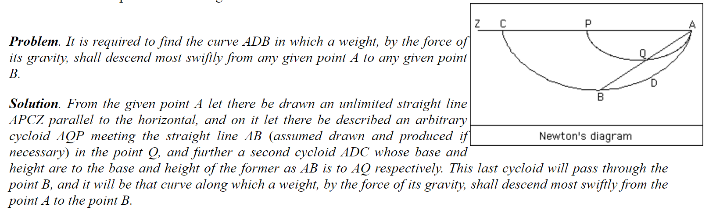  
  
**Extra credit problem: can you come up with the proof as to why the Cycloid is the particular curve that satisfies problem?**

**Additional Suggested Reading**: Epilogue, Chapter 8

**Assignment:** Challenge of the Brachistochrone - challenge problem (optional)